|  |  |  |  |  |  |  |
| --- | --- | --- | --- | --- | --- | --- |
| QUOTATION | | | | | | |
| **DATE** | | **EXPIRATION DATE** | | | | **REVISION/VERSION** |
| Mon Mar 24 2025 | | Mon Mar 31 2025 | | | | 2 |
| **FROM**: Example Shedmate Standard Cold Formed | | | **TO:** SAMPLE SM-TRAINING | | | |
| , | | | Melbourne | | | |
| Phone:  Email: sales@shedmate.com.au  Website: https://www.shedmate.com.au | | | Phone: 0887418181  E-mail: sales@shedmate.com.au | | | |
|  | | | | | | |
| Example Shedmate Standard Cold Formed appreciates the opportunity to provide you with a quotation for your new building. Please find below all project information, details, specifications, inclusions, exclusions, plans, terms and conditions and payment details.  This proposal is valid until Mon Mar 31 2025 and is subject to the site classification and engineering data. We look forward to being of assistance to you.  Anything discussed or implied not detailed in this quote has not been allowed for in the quoted price. Please contact us if you require anything extra, and we will send you a revised quotation. | | | | | | |
|  | | | | | | |
| **PROJECT INFORMATION AND SITE LOCATION** | | | | | | |
| **Project Name** | SMTRAINING-SAMPLE-10-DRAFT-3-2025 | | | | | |
| **Site Address** |  | | | | | |
| **Council** |  | | | | | |
| **Coordinates** |  | | | | | |
| **Responsible** | Demo Shedmate | | | | | |
|  | | | | | | |
| **BUILDING SPECIFICATIONS** | | | | | | |
| **Span Width** | 12000mm | | | | | |
| **Length** | 18000mm | | | | | |
| **No of Bays** | 4 | | | | | |
| **Height** | 4200mm | | | | | |
| **Roof Type and Material** | Gable End – Trimdek Terrain | | | | | |
| **Roof Pitch** | 15 | | | | | |
| **External Walls and Trim Material** | Trimdek Terrain | | | | | |
| **Insulation** | Roof – None  Side Walls – None  End Walls – None  Internal Wall – None | | | | | |
| **Roller Doors** | Roller Door: Series A Terrain: 3m(H)x3m(W) (1x) | | | | | |
| **Roller Door Motors** | Rollerdoor Motor Right: Series A: 3m(H)x3m(W) (1x) | | | | | |
| **PA Doors** | No PA Doors | | | | | |
| **Windows** | Glass Window: Ultra Silver Dowell Standard: 1200mm(H)x1500mm(W) (2x) | | | | | |
| **Glass Doors** | No Glass Doors | | | | | |
| **Sliding Doors** | Sliding Panel: Terrain: 4030mm(H)x4000mm(W) (3x) | | | | | |
| **Open Bays** | No Open Bays | | | | | |
| **Skylights** | No Skylights | | | | | |
| **Spin Aways** | No Spin Aways | | | | | |
| **Gutters** | Square Fascia Gutter (ST15) – Gutter: Terrain | | | | | |
| **Flashings** | Ridge Caps: Ridge Cap: Terrain: 6083mm (3x)  Barge Trims: Barge Trim: Terrain: 6294mm (4x)  Wall Corner Flashings: Wall Corner: Terrain: 4240mm (2x) | | | | | |
| **Down Pipes** | Circular PVC: Down Pipe: 4100mm (2x) | | | | | |
|  | | | | | | |
| **STEEL STRUCTURE DETAILS** | | | | | | |
| **Columns** | C:200-24 | | | | | |
| **Open Web Trusses** | SHS:30x30x2.0 | | | | | |
| **Trusses** | C:200-24 | | | | | |
| **Mullions** | C:150-24 | | | | | |
| **Purlins** | TH:96-75 | | | | | |
| **Girts** | TH:96-75 | | | | | |
| **Fascia** | C:100-10 | | | | | |
| **Bracings** | Strap:40-2 | | | | | |
| **Fly Bracings** | Strap:40-2 | | | | | |
| **Bridging Beams** | No Bridging Beams | | | | | |
|  | | | | | | |
| **OPTIONAL EXTRAS (IF ANY)** | | | | | | |
| **Description:** | | | | | **Additional Cost (incl. GST):** | |
|  | | | | |  | |
|  | | | | |  | |
|  | | | | | | |
| **CONCRETE DETAILS** | | | | | | |
| **Concrete Slabs** | Concrete 25Mpa | | | | | |
| **Aprons** | Concrete 25Mpa | | | | | |
| **Concrete Reinforcements** | Reinforcement Meshes SL72 | | | | | |
| **Column Footings** | 600mm x 1250mm | | | | | |
| **Mullion Footings** | 450mm x 700mm | | | | | |
|  | | | | | | |
| **INCLUSIONS** | | | | | | |
|  | | | | | | |
|  | | | | | | |
| **EXCLUSIONS** | | | | | | |
|  | | | | | | |
|  | | | | | | |
| **GENERAL SPECIFICATIONS** | | | | | | |
| * Example Shedmate Standard Cold Formed reserves the right to make design and engineering changes before manufacturing begins. The engineer’s final design requirement may override anything nominated. * **Standards & Codes** – All buildings are designed by test results, computer analysis, NCC, AS/NZE 1170, AS 3600, AS 4100 and AS 4600 * Design based on Wind Category: Reg wind speed 41m/s and Terrain Category: 2.0. * All Australian-made steel products * All Class B8 screw fasteners | | | | | | |
|  | | | | | | |
| **QUOTE DETAILS** | | | | | | |
| **Supply Only** | | | | $32902.54 | | |
| **Brackets** | | | | $995.45 | | |
| **Structural Steel and Fabrication** | | | | $1111.33 | | |
| **Administration** | | | | $500 | | |
| **Erection** | | | | $0 | | |
| **Erection (% of Shed Kit)** | | | | $0 | | |
| **Concrete** | | | | $0 | | |
| **Concrete Labour** | | | | $0 | | |
| **Delivery** | | | | $330 | | |
| **Engineering** | | | | $1732.50 | | |
| **Council Fees** | | | | $0 | | |
| **Council Fees (No GST)** | | | | $0 | | |
| **Total incl. GST** | | | | $36460.49 | | |
|  | | | | | | |
| All pricing indicated in this quote includes GST | | | | | | |
| Quotation prepared by: Demo Shedmate | | | | | | |

|  |  |
| --- | --- |
|  | |
| **NEXT STEPS - CONFIRMATION OF ORDER** | |
| In accepting this quote and proceeding to the order stage you acknowledge and agree to the following:   * Once you have accepted your quote and a site visit has occurred, a $300 charge will apply if you later cancel your shed. * The following Payment Schedule will apply:  |  |  |  | | --- | --- | --- | | **Payment Schedule** | | | | Deposit at Accepting Quote | 60% | $21876.29 | | Final Payment | 40% | $14584.20 | | **TOTAL** | | $36460.49 |  * You confirm to proceed with the Optional Extra/s ticked below (if any):  |  |  |  | | --- | --- | --- | | **Optional Extras (if any)** | | | | P | Description: | Additional Cost: | |  |  |  | |  |  |  | |  |  |  |   Note – any selected optional extras will need to be added to your final contract price. The above Payment Schedule will need to be updated accordingly.   * Upon receiving the signed acceptance of your quote, COMPANY will send you an invoice for the deposit payment. Your job will not proceed any further until the deposit invoice has been paid. * I hereby agree to place this order based on the details and terms and conditions provided in this quote. | |
| **Quotation Date:** | Mon Mar 24 2025 |
| **Revision / Version No:** | 2 |
| **Customer Name:** | SAMPLE SM-TRAINING |
| **Customer Signature:** |  |
| **Date:** |  |

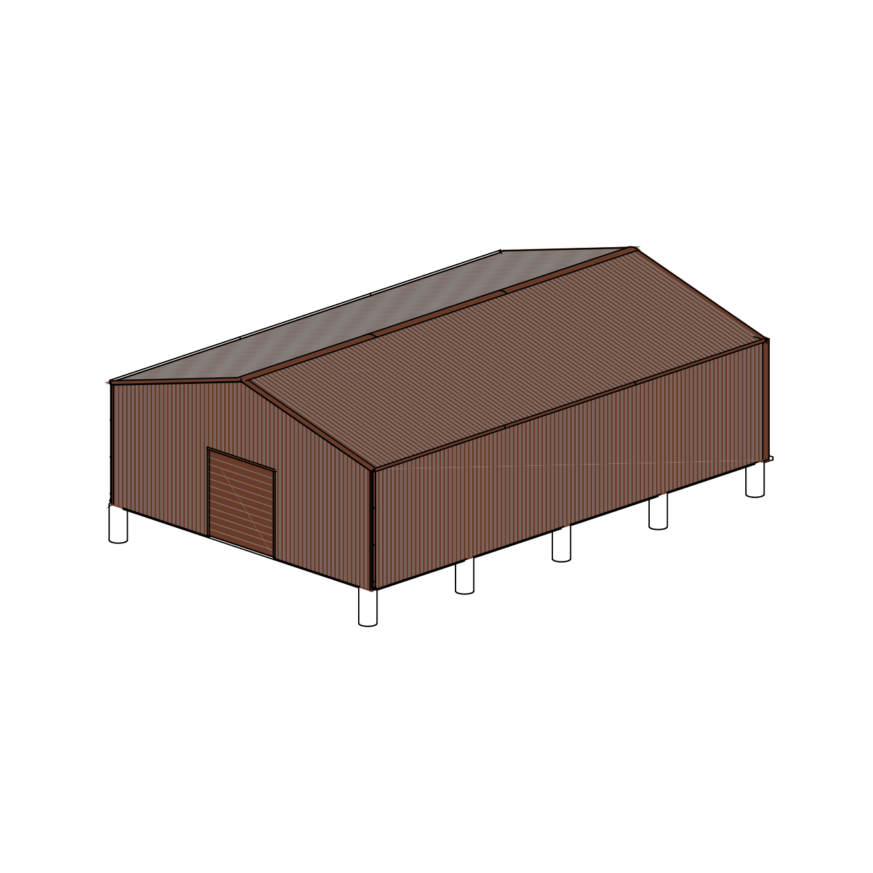

**3D IMAGE**

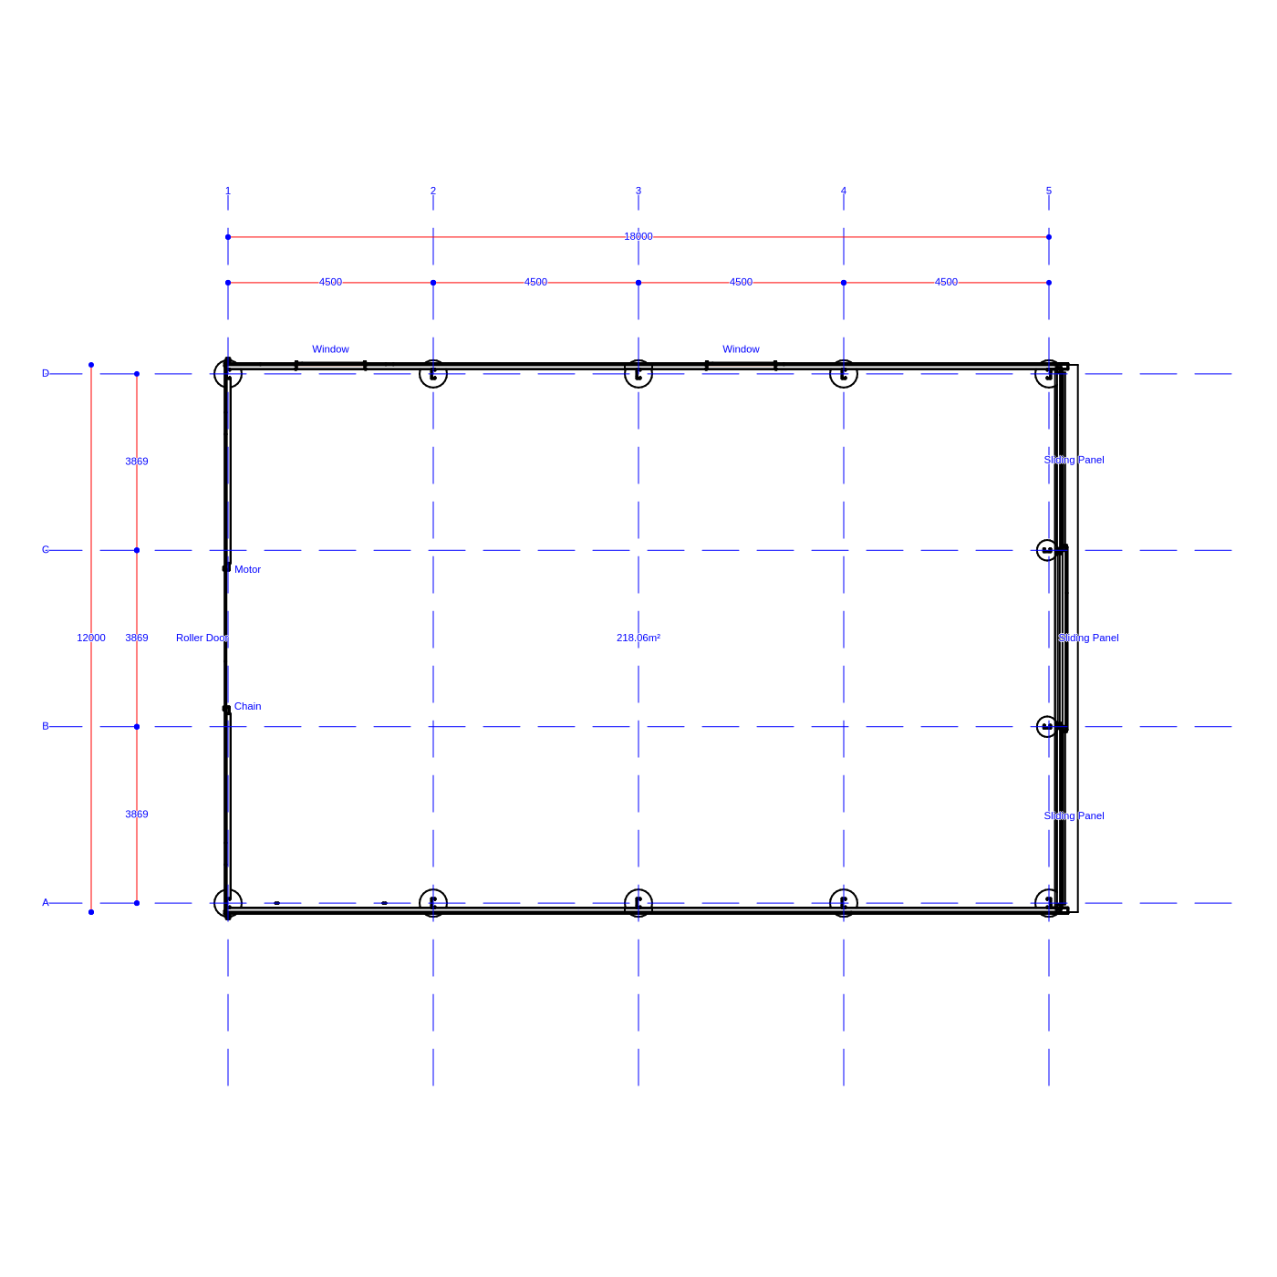

**FLOOR PLAN**

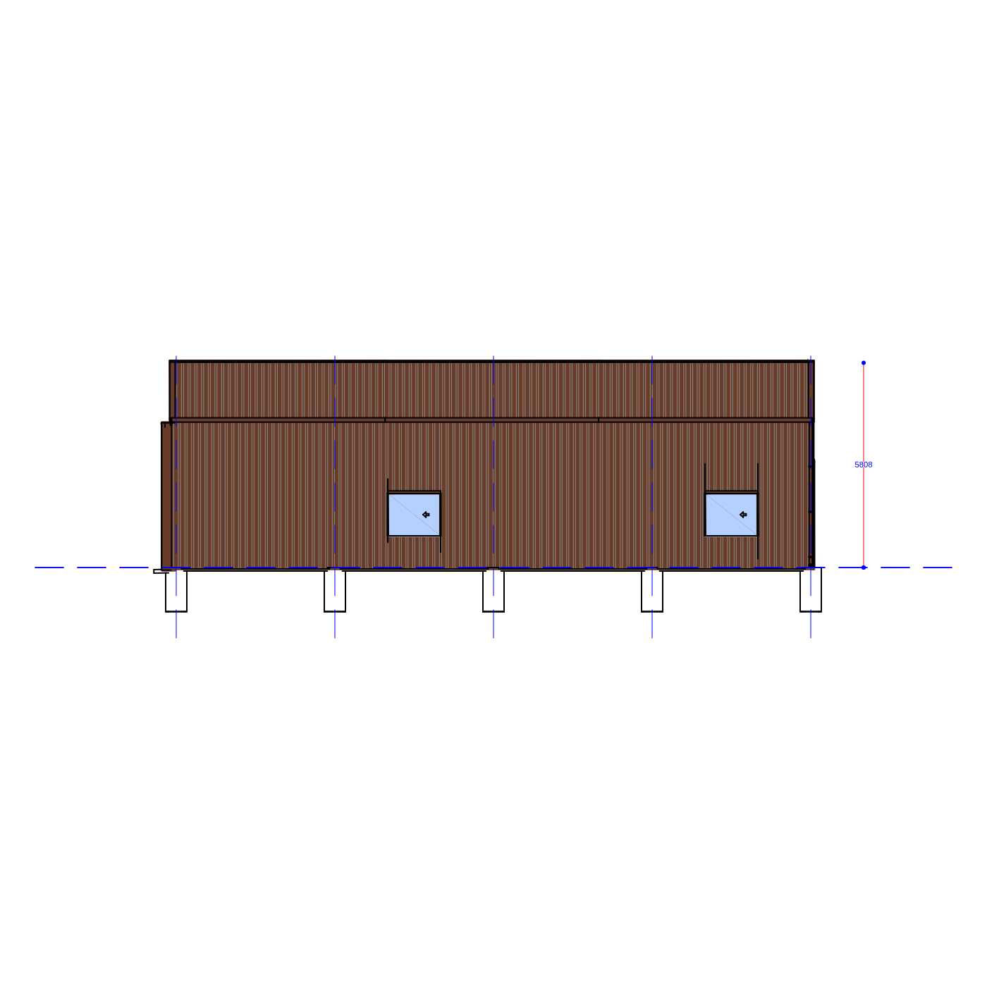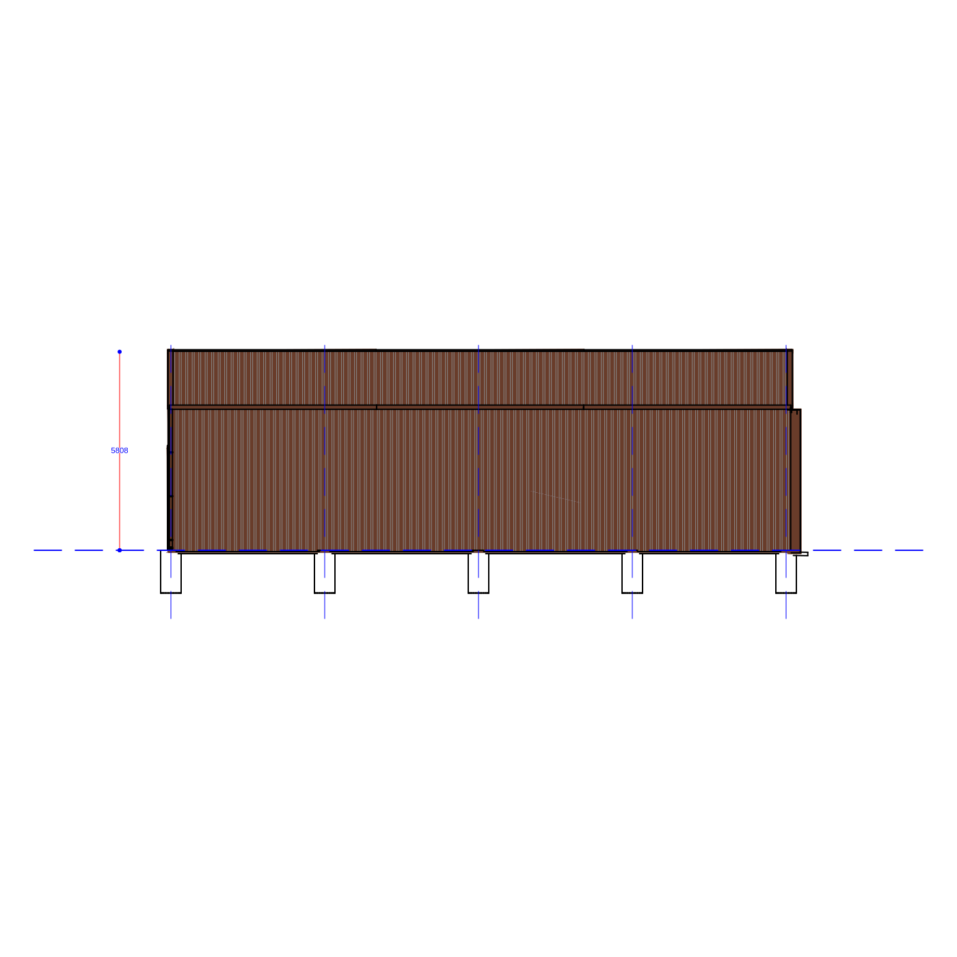**8**

**ELEVATION 2**

**ELEVATION 1**

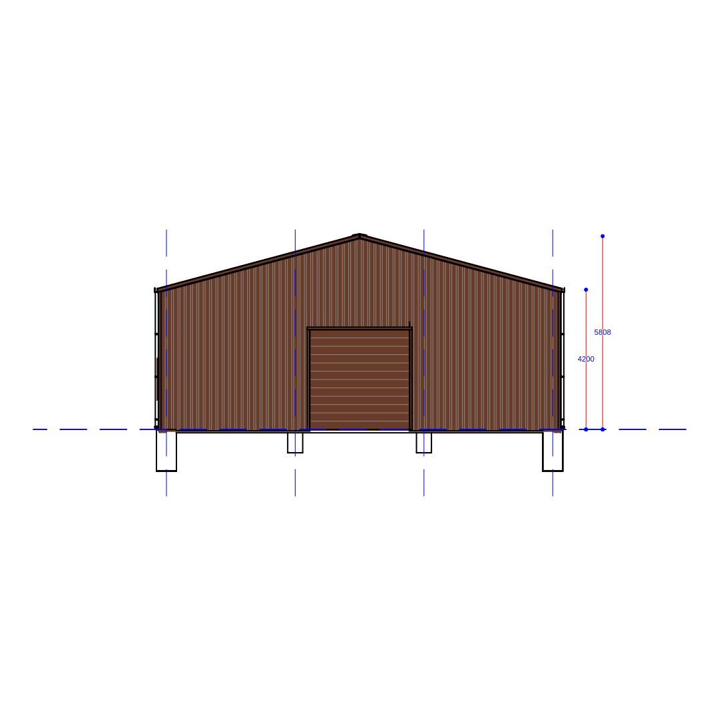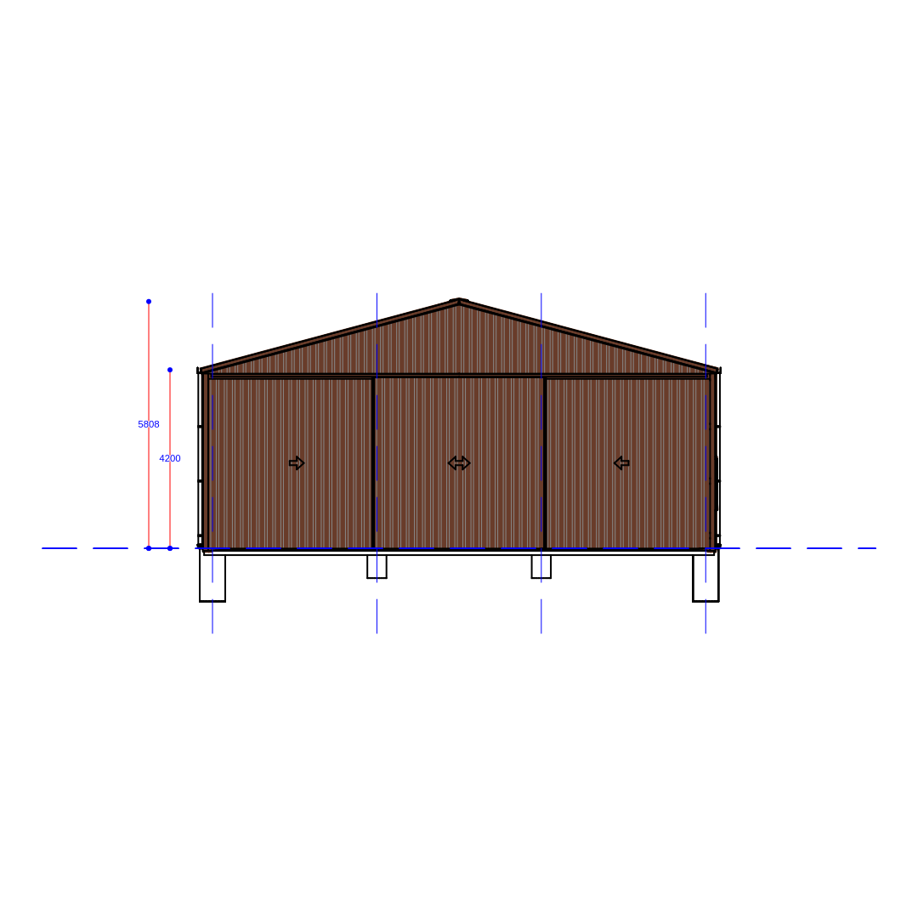

**ELEVATION 4**

**ELEVATION 3**